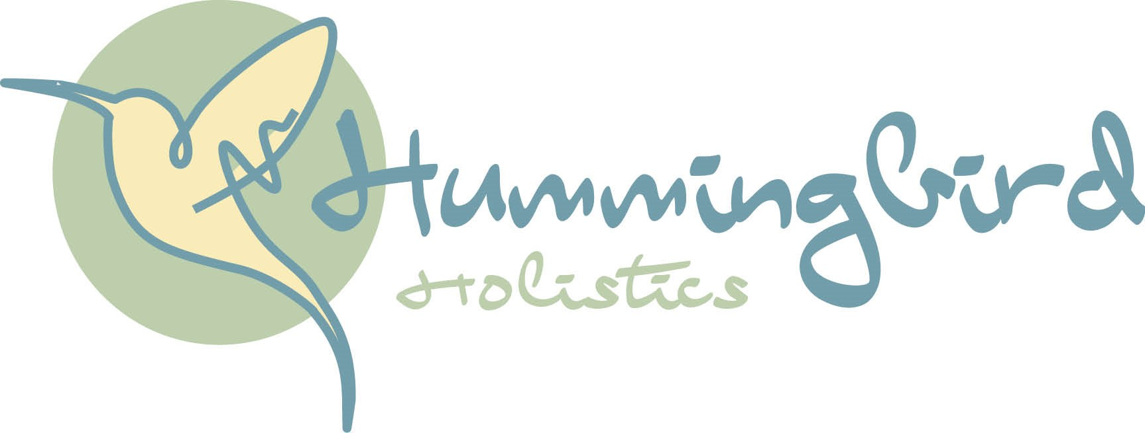

**Data Privacy Policy Hummingbird Holistics/Little Hummingbird**

This privacy policy sets out how Jane Connor founder Hummingbird Holistics/Little Hummingbird protects any information given.

Jane Connor may change this policy as and when required and you can request a copy of this document by emailing [jane@hummingbirdholistics.co.uk](mailto:jane@hummingbirdholistics.co.uk)

**What** **we collect and what we do with that information**

Your personal information for treatment/class purposes only. The consultation form/class booking will reflect the required information needed for each and may be different.

We require this information to understand your treatment/class requirements, and keeping in touch.

**We may collect the following**

Name, address, DOB, contact details, next of kin, brief medical history (treatment purposes only).

**What we do with the information we gather.**

Internal record keeping

Promotional emails when we have information about new therapies/classes that might be of interest to you. If you agree to being contacted, you will be asked to give a preference on how we contact you.

**You can change your preferences or remove your consent at any time by contacting** [jane@hummingbirdholistics.co.uk](mailto:jane@hummingbirdholistics.co.uk)

We are committed to ensure that your information is secure both in the physical, electronic and within our required data holding for treatment purposes. We comply with GDPR regulations, so your data is not shared or used without your permission. You may request information that we hold on you under the data protection Act 1998, a small fee will be payable.

Last updated 19.08.2023.